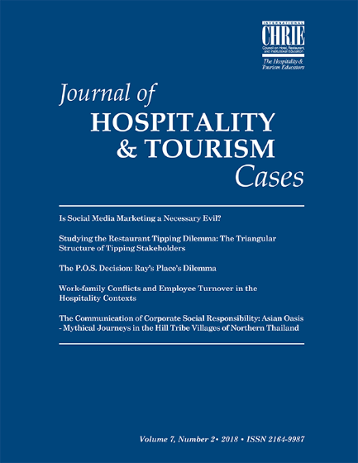
GUIDELINES FOR WRITING CASE STUDIES & TEACHING NOTES

The Journal of Hospitality & Tourism Cases (JHTC) is an international refereed electronic journal (e-journal) published by ICHRIE. To submit a case study the team ask you to follow the following guidelines.

- Case studies may be compiled from field research, published sources and/or generalised experience.

- The case studies may refer to any topic and subject area related to the tourism and/or hospitality field and industry.

- The case studies must be of maximum 5,000 words excluding figures, tables, annexes and bibliography. Each case study submission must be accompanied by a teaching note for which there is no world limit (although a teaching note of a minimum of 1,000 words is expected).

- Case studies do not have to follow a specific structure. However, each case study is expected to include sections related to the following topics:

- a background of the subject organisation and/or of the topic;
- an analysis of the dilemma and/or the teaching objective;
- a section explaining the questions and dilemmas of the case study;
- related bibliography and additional reading.

- Teaching Notes are an important aspect of a case study. They should lead the instructors (and specifically, the less experienced case users) through the case study by supporting the design and the execution of the teaching of the case study. Thus, the Teaching Note should aim to make the teaching of the case study an interesting and successful process. The Teaching Note does not have to conform to a standard structure, but it should contain sections that address the following issues: a case study summary; the teaching objectives and the target audience; the recommended teaching approach and strategy; additional suggested readings and/or references.

- The case studies and the Teaching Note will be evaluated against three criteria: content, theoretical underpinning, and presentation. For more information about the review process and criteria of case studies and teaching notes, please read the following section.

- All case studies and Teaching Notes must adhere and follow the submission guidelines of case study writing. All Case studies should also be written by following JHTC template format, which is found at. For more information about the submission guidelines, please read the file named Guidelines to authors of JHTC.

GUIDELINES FOR SUBMITTING CASE STUDIES AND TEACHING NOTES

All case studies, teaching notes and related material should be submitted through the EasyChair online platform. To access the site, you will first need to complete the pre-submission form through the ICHRIE website. For more information about the submission guidelines and for downloading the templates for writing your case study, please click here and read the files related to "Case Study Submission Information."

REVIEW PROCESS AND ASSESSMENT CRITERIA OF CASE STUDIES

- JHTC is a refereed publication, meaning that all case studies and teaching Notes are subject to a rigorous double-blinded peer-review process. The editor of JHTC is responsible for allocating the submitted case studies to three anonymous evaluators and for managing the review process. Reviewers are selected based on the relevance of the topic/subject of the case study to the reviewers’ expertise and credentials. All reviewers participating in the case study review process are listed in the Review Board of the relevant issue of JHTC.

- JHTC follows a supportive and constructive editorial policy to the authors. All authors would be provided suggestions and ideas on how to improve the case study and they would be encouraged to resubmit an enhanced version. It is the aim of JHTC to work with authors in achieving their research and publication goals.

- Case studies may have been already tested in the classroom. If this is the case, the case study author(s) may also submit evidence of the educational effectiveness and impacts of the case study. Any such evidence will also be considered by the competition judges when evaluating the case studies.

- The case studies and the teaching notes are evaluated against three major criteria: content, theoretical underpinning, and presentation. The following analysis further explains the criteria that reviewers use for evaluating case studies and providing constructive to authors.

Evaluation Criteria for content and theoretical background
Case studies must:

- be topical and relevant to current tourism and hospitality issues
- be engaging in order to deliver an interesting learning experience in the classroom
- explicitly identify, explain and support the teaching objectives of the topic subject
- thoroughly analyse the theoretical concepts and framework that underpin the topic of the case study
- include questions / management dilemmas that will be able to probe class discussions and debates around the teaching objectives, the case study topic and/or the theoretical concept
- any tables, figures, exhibits, annexes and/or supplementary items should also explain and
- support the teaching objectives and theoretical concepts. There is not any (min/max) limit about the number of figures/tables that a case study can include. However, case studies will also be evaluated based on the appropriateness, the educational value and the explanatory power of the figures / tables that they include.

Teaching notes must include:

- a summary of the case
- an explanation of the teaching objectives and target audience
- the recommended teaching approach and strategy to be adopted by other educators
- analysis of the teaching objectives and the theoretical concepts
- additional readings and/or references

Presentation Criteria
The presentation of the case studies and teaching notes are judged on the following areas:

- quality of English
- readability
- clarity of format - presentation of information and data
- a well-defined structure

